2021 年昔华国民型华文中学行政人员
2021 SMJK Seg Hwa School Admin
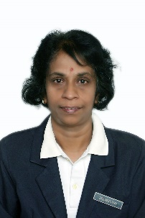
 |  |  | Principal 校长
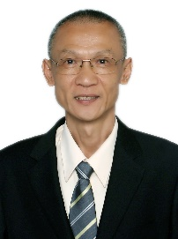

Mr. Tai Chen Kiun
戴正钧
Senior Assistant / 副校长
Students' Affairs学生事务部 |  |  | Academic学术及行政 |  |  | Co-curricular 课外活动
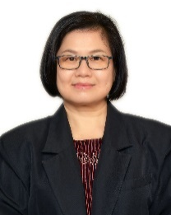  Mdm. Tey Ah Kuan  郑雅宽 |  |  | 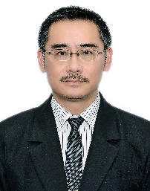  Mr. Shia Kee Loong  谢麒论 |  |  | 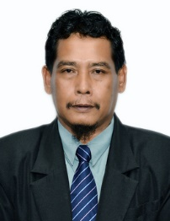  Mr. Rasid Bin Md. Jais  拉昔加斯
 | Afternoon Session下午班 |  |  | Sixth Forms大学先修班
 | 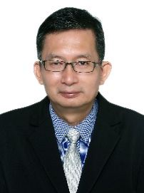  Mr. Tee Chai Seng  郑再兴 |  |  | Mdm. Selvasothy A/P Selvaratnam  思拉瓦淑蒂
Head Of Department / 科主任
Language  语文 |  | Science & Maths  数理 |  |  | Social Science  人文 |  | Technique & Vocational  工艺
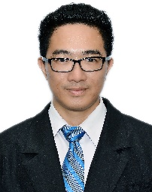  Mr. Hiew Soon Yong  邱顺荣 |  | 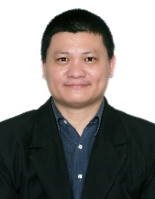  Mr. Goh Jit Siang  吴翊彰 |  |  | 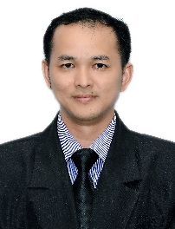  Mr. Chan Chee Choy  陈咨材 |  | 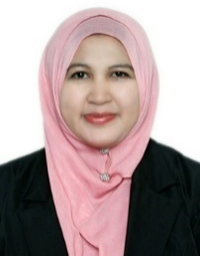  Mdm. Norhayati Binti Mohd Salleh  诺哈雅蒂

