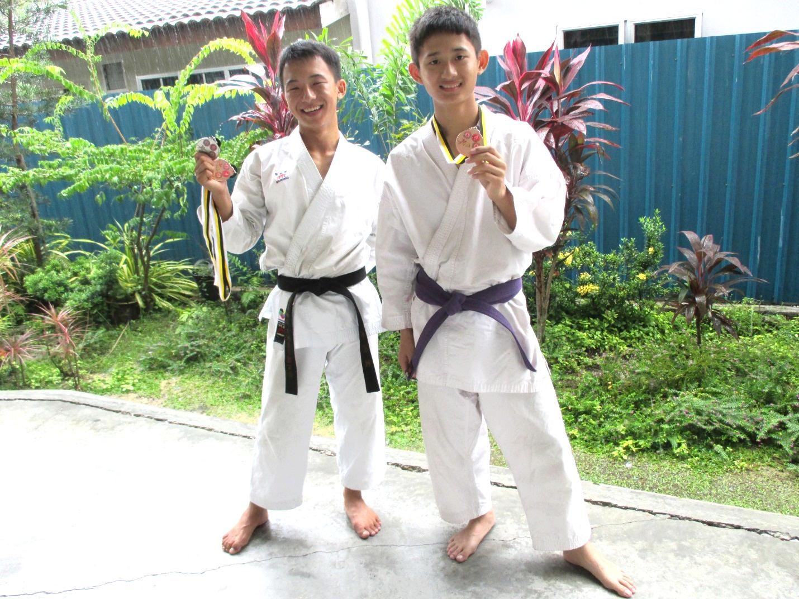

lim ye seng (5a3)

– Pingat Emas Negeri Male Individual Kata Open,

Pingat Emas Negeri Mix Team Kata

Cheah Joo Hoong (4A2)

– Pingat gangsa Negeri male Individual Kumite open below 65 kg

5th K.O Game Aka Interschool Karate-Do Championship