Exercise Chapter 2: Cell Structure and Cell Organisation Paper 2 Form 4

Name | : |  |  | Class | :

1. | Diagram 1.1 shows an animal cell as observed under an electron microscope.
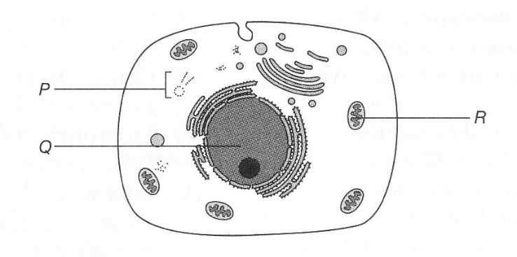

Diagram 1.1

(a) | (i) | Name the structures P and R.
 | P | :
 | R | :
 |  |  | [2 marks]

 | (ii) | State one similarity between structures Q and R.
 |  | [1 mark]

 | (iii) | Explain the importance of the similarity between structures Q and R that you have mentioned in 1(a)(ii).
 |  | [1 mark]

 | (iv) | Explain one characteristic of structure R which enables it to carry out its function efficiently.
 |  | [2 marks]

(b) | Diagram 1.2 shows that animal cells undergo process X to form phagocytic white blood cells.
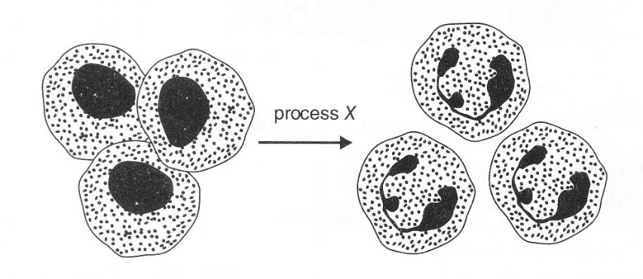

Diagram 1.2

 | (i) | Name process X.
 |  | [1 mark]

 | (ii) | State the type of defense mechanism in which the white blood cells in Diagram 1.2 fight against the pathogens.
 |  | [1 mark]

 | (iii) | Based on your answer in 1(b)(ii), name one example of the white blood cell in Diagram 1.2 and explain how the white blood cells defend the body against bacterial invasion.
 |  | [4 marks]

